Mung Bean Germination

**Background**

­­During a lifeform’s growth and development, whether it be animal or plant life, is dependant of a lot of different factors. These factors can be almost anything really, from things like sunlight, food, area of development, the development of other lifeforms around it. With animals, there is dependency on things like psychological health as well. There are tons of different things that affect the way something grows. The one thing that all life on planet Earth is dependent on, no matter what, is water, more specifically hydration. All life is comprised of some percentage of water, with humans having a composition that is about 50-70% water, although there are some lifeforms that are made up of much higher amounts, as seen in some microscopic life.

Salt is a term for crystalized acids. Salt comes in varying levels of acidity and each salt’s composition can be made up several different things. In this context, where in this investigation I use the term ‘salt’, I will be referring to Sodium Chloride (NaCl). One of salts abilities’ is to draw water towards it from around it. Salt is naturally soluble in water, meaning that it will dissolve to create a solution (salt water). Even when it is dissolved, it will still naturally draw water towards itself.

Plant roots have a similar property. To feed it water, the plant will draw up water from around it’s’ roots. The water is then transported throughout the plant, mainly to be used for photosynthesis. The stream can also contain nutrients for the plant. Obviously then, water is extremely crucial for a plant’s growth and survival.

So, how will the plant be affected when the water that is being drawn up contains salt?

**Hypothesis**

My hypothesis is that salt will have an effect on a plant’s growth, specifically that the salt will be detrimental to plant, inhibiting it from growing. I base this hypothesis on the information stated above; where salt pulls in water, as does a plant, meaning the salt will prevent a plant getting the hydration and nutrients it needs.

**Test**

My test will be to follow the growth of mung beans in a controlled environment. Mung beans take only 1-2 days to germinate normally, if exposed to the right amount of water and light. My plan is to grow mung beans alongside each other, using a solution that contains between 0 – 0.3 moles* of salt. The experiment will take place over 5 days. The concentration of salt in the solution will be measure in 0.05 mole increments. So that’s 7 different salt concentrations.

Each concentration level will have a petri-dish containing 10 mung beans, with 7 repeats also in that level. That’s a total of 8 petri-dishes containing 10 mung beans, each contains a solution of different salt concentration. That’s means there will be: (8 x 7 x 10) mung beans, which gives a total of 560 beans.

The solution will be created by measuring out 80ml of distilled water, then adding the salt. Each petri-dish will then been given 10ml of the solution. 1ml per bean.

The test will commence at 12:00PM on day 0, where none of the beans will have germinated. Each day afterwards, at 12:00PM I will inspect each petri-dish and record how many beans have germinated in that dish. When a bean germinates, it is removed from the dish. This will carry on for 5 days, where the test will end.

*\*Moles: A unit used when measuring an amount of substances. It is not a measurement of mass (i.e. grams)*

**Data**

As stated above, I will record each petri-dishes’ total seed germination each day. I am keeping the test as absolutely fair as possible, to make sure the results are as valid as possible. All the seeds will be stored in the same condition (in darkness, room temperature). Each petri-dish will have the same amount of solution, differing only in salt concentration, as that is the independent variable. 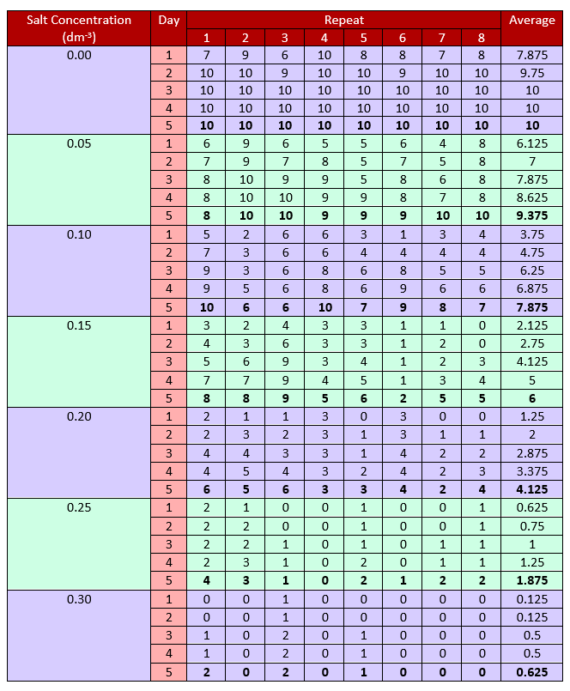

Bold – Final Germination Result

As we can observe on the previous side, the concentration of salt has clearly had a negative effect on the germination of the mung bean seeds.

Here is a graph representing changing germination averages of each salt concentration over the 5 days:

As we can see, the lower the salt concentration, the higher the germination at any given point.

Here is a small containing just concentration and final germination average:

|  |  |  |  |  |  |  |  |
| --- | --- | --- | --- | --- | --- | --- | --- |
| Salt Concentration (dm-3) | 0.00 | 0.05 | 0.10 | 0.15 | 0.20 | 0.25 | 0.30 |
| Final Germination Average | 10 | 9.375 | 7.875 | 6 | 4.125 | 1.875 | 0.675 |

Using this data, we can find out if there are any erroneous results that should be ignored for the sake of validity. To this, we will calculate the standard divination for each concentration

|  |  |  |  |  |  |
| --- | --- | --- | --- | --- | --- |
| Salt Concentration (dm-3) | Final Germination Average | Standard Divination | Average + 2(Standard Divination) | Average - 2(Standard Divination) | Erroneous values outside range |
| 0.00 | 10 | 0.690 | 10.905 | 8.145 |  |
| 0.05 | 9.375 | 1.323 | 10.445 | 5.155 |  |
| 0.10 | 7.875 | 2.184 | 10.2675 | 1.5325 |  |
| 0.15 | 6 | 2.019 | 8.0375 | -0.0375 |  |
| 0.20 | 4.125 | 1.021 | 4.7675 | 0.6825 |  |
| 0.25 | 1.875 | 0.196 | 1.4925 | 0.7075 |  |
| 0.30 | 0.625 | 0.044 | 0.4625 | 0.2875 |  |